D.SARATH BABU-192311031

**EXP NO 2:**

**CREATE A SIMPLE CLOUD SOFTWARE APPLICATION FOR FLIGHT RESERVATION SYSTEM USING ANY CLOUD SERVICE PROVIDER TO DEMONSTRATE SOFTWARE AS A SERVICE (SAAS).**

**AIM:**

To create a simple cloud software application for flight reservation system using any cloud service provider to demonstrate saas.

**PROCEDURE: step1:** Go to zoho.com. **step 2:** Log into the zoho.com. **step 3:** Select one application step. **step4:** Enter application name as flight reservation system. **step 5:** Created new application flight reservation system.

**step 6:** Select one form **step 7:** The software has been created.

**IMPLEMENTATION:**

# STEP1: GOTO ZOHO.COM

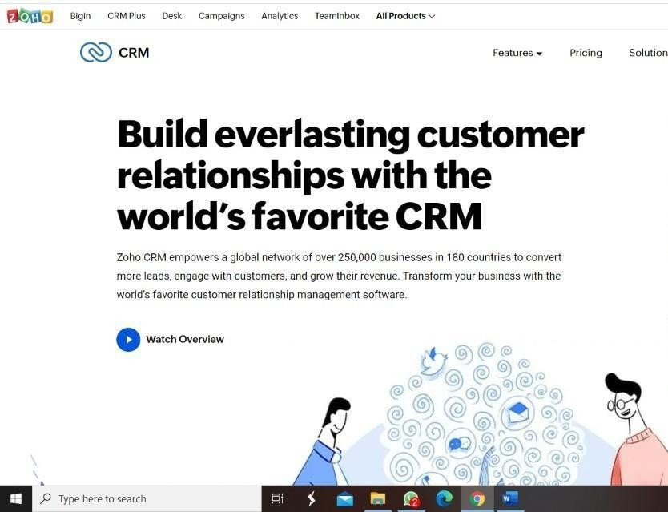

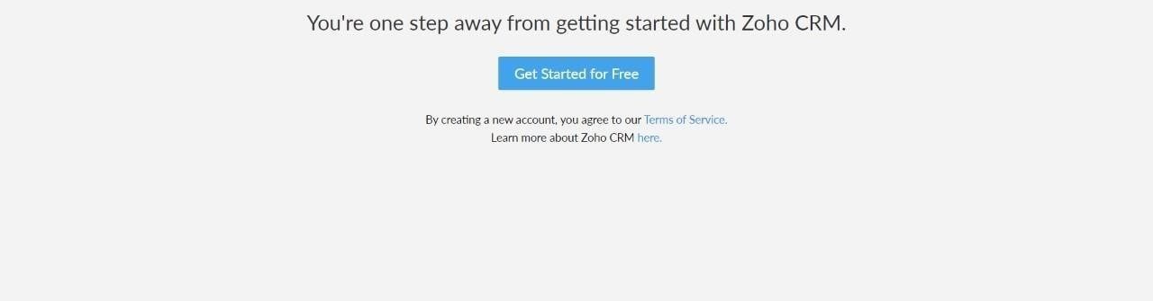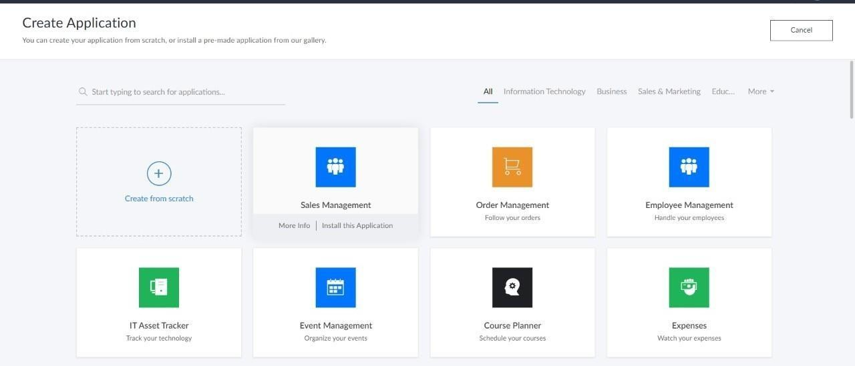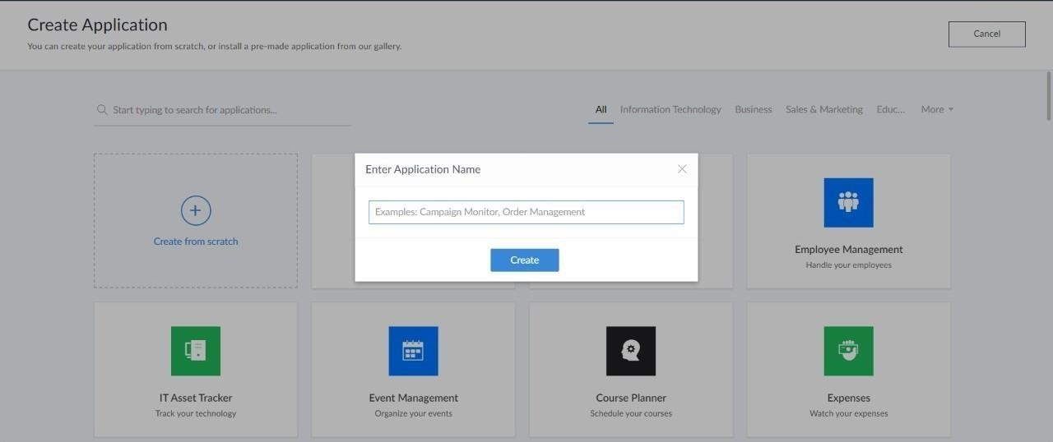**STEP 2: LOGINTOTHE ZOHO.COM**

**STEP 3: SELECT ONE APPLICATION**

**STEP 4: ENTER APPLICATION NAME**

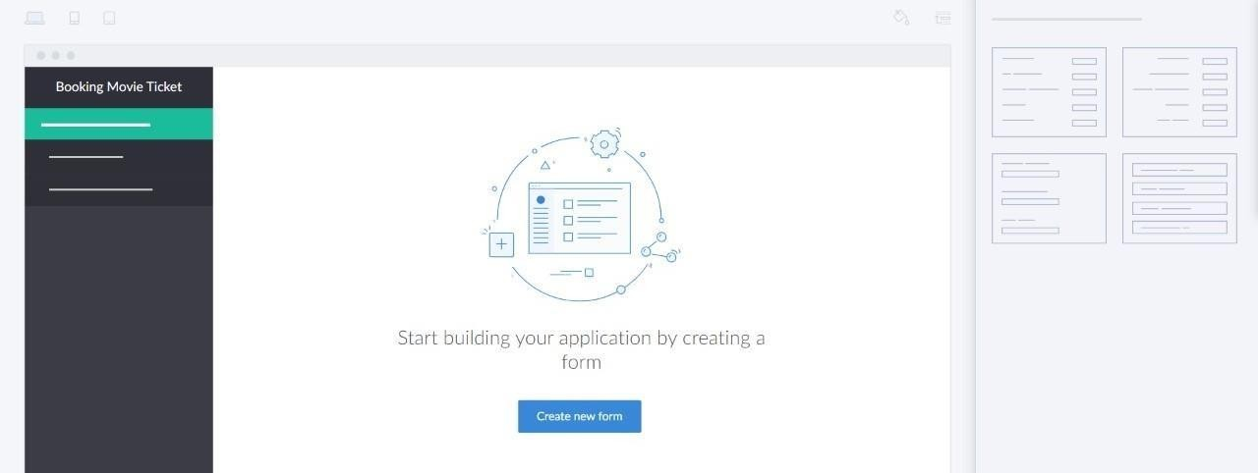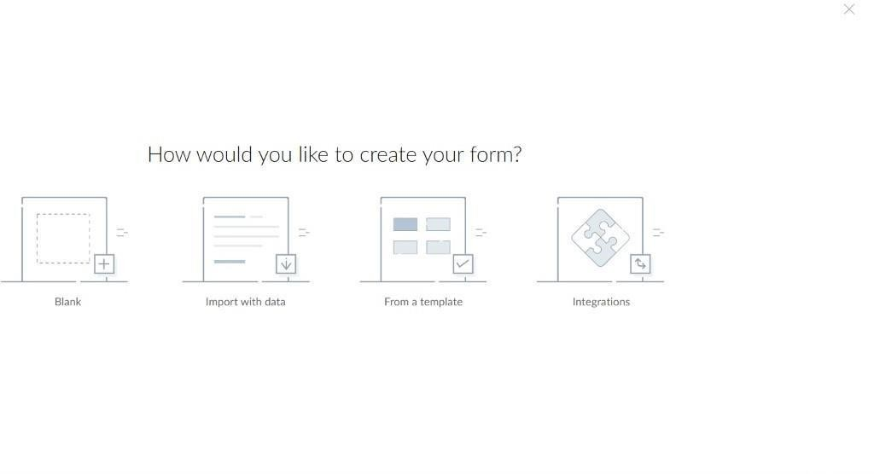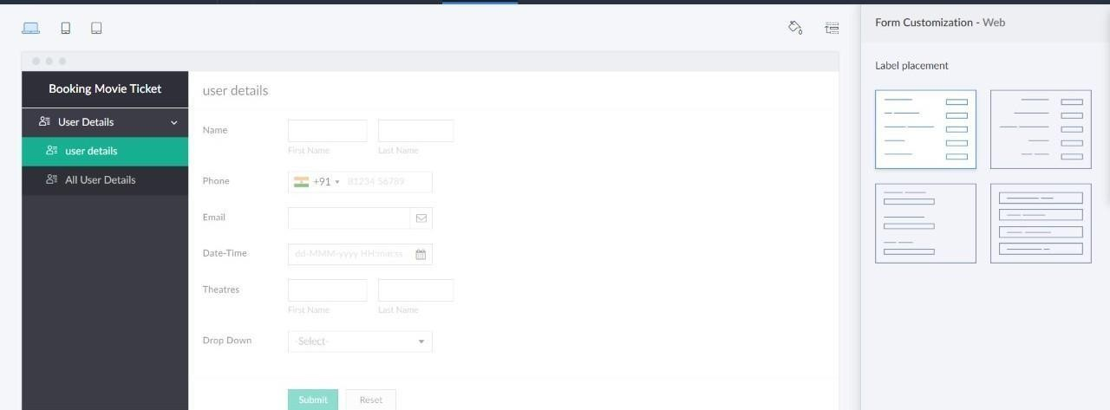**STEP 5: CREATED NEW APPLICATION**

# STEP 6: SELECT ONE FORM

**STEP 7: THE SOFTWARE HASE BEEN CREATED.**

